|  |  |
| --- | --- |
| Assessment Title | Select and implement the API |

## Competency Details

|  |  |
| --- | --- |
| Unit code/s and title/s | ICTPRG553 – Create and develop REST APIs |
| Qualification code/s and title/s | ICT50220 Diploma of Information Technology |
| Business unit/Work group | Business and Arts/IT Studies |

## Instructions

|  |  |
| --- | --- |
| Method/s of assessment | Product (Screenshots as evidence)  Questioning (Written)  Product (JavaScript Code) |
| Overview of assessment | This assessment will require you to:   * Complete written questions within this document. * Provide screen captures for written questions within this document. * Complete JavaScript code for API development |
| Task/s to be assessed | This assessment will require you to complete the following tasks  Task 1 – Information about the project  Task 2 – Build the API |
| Time allowed | Refer to your schedule for submission dates |
| Location of assessment | Assessment can be completed anywhere with access to the resources required. (See Resources Required section below) |
| Decision making rules | To receive a satisfactory outcome for this assessment you must complete all parts correctly.  Word counts are provided as guidance only. |
| Assessment conditions | This assessment must be undertaken where conditions are typical of a work environment requiring cyber secure practices, processes, and procedures.  This is an unsupervised assessment, and you may access any required resources.  You can complete on your own computers or laptops at home if you are able to source the resources requirements (see next section). |
| Resources required | To complete this assessment, you will require the following:   * Visual Studio Code * Internet access * Microsoft Word * Microsoft Windows 10/11 * Node.js * AdonisJS   You can complete on your own computers or laptops at home if you are able to source the above requirements. |
| Result notification and reassessment information | You will be provided feedback and the result for your assignment on TAFESA Learn. You will be and given the chance to resubmit with required corrections only once.  Refer to the TAFE SA assessment policy for more information <https://www.tafesa.edu.au/apply-enrol/before-starting/student-policies/assessment> |

**SCENARIO**

You have been employed by the ITWorks organisation as a junior programmer and you have previously done some work with JavaScript. A client has come to ITWorks with a large project which has a short time frame for completion. This project is a student enrolment system where students can register themselves into their studies using a web application.

This sort of application will be back end heavy as a great deal of data will be stored and retrieved from back-end systems.

ITWorks senior developers believe that an Application Programming Interface (API) would be valuable for this project for retrieving backend information and you have been tasked with doing some preliminary research and implementation for the enrolment system API. The work that you do will be built upon in the future should the client and senior developers be happy with your results.

You have been given 6 weeks by ITWorks management to complete this project along with your other duties.

Your ITWorks team has some experience already with JavaScript frameworks and are interested in using AdonisJS and Visual Studio Code for more projects moving forward. Visual studio code has been highlighted for the ability to add extensions, the excellent JavaScript language support, and the ability to connect projects to GitHub for collaboration.

**Task 1: Information about the project**

**Question 1:**

Referring to the above scenario and the decision to create an API for the student enrolment system, list four benefits of creating an API for such a project.

How long has ITWorks management scheduled for this API Project to be completed?

6 weeks

**Question 2:**

The senior developers would like some more information about the selected technologies.

1. List the framework that has been selected for this project

AdonisJS

1. Provide a review on the framework you listed above (Approximately 50 words). Include in your review:
   * What is a framework?
   * Why use this framework?
   * Languages supported by the framework

Frameworks are packages that provide a basic “framework” for an application that programmers can build off, Adonis provides a more robust framework that can be used for scalable web services, Adonis uses TypeScript as its main language

1. Provide an evaluation on how the framework meets the needs of the client (Approximately 30 words)

**Question 3:**

The senior developers would like some more information about the selected technologies.

1. Provide a general review on the Visual Studio Code IDE. (Approximately 50 words)
2. Provide an evaluation about how Visual Studio Code meets the needs of the client and the project (Approximately 40 words)

**Question 4:**

Create the API project in Visual Studio Code using the JavaScript framework ITWorks is using for this project. Name the project “StudentEnrolmentSystem”. Provide a screenshot of the created project in the IDE.

**Screenshot of command to create the API project and of project folder structure:**

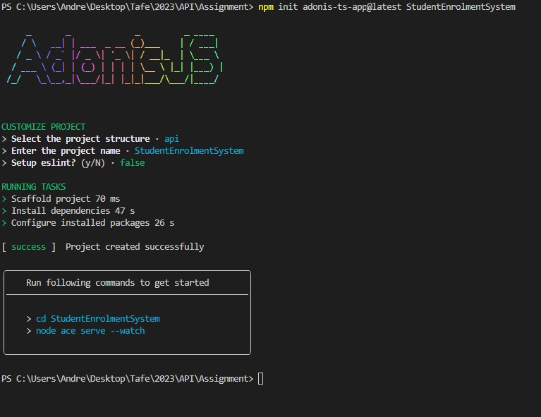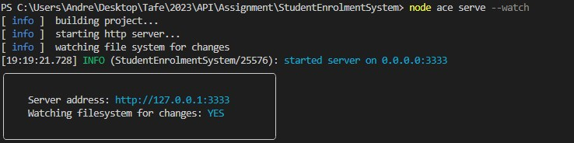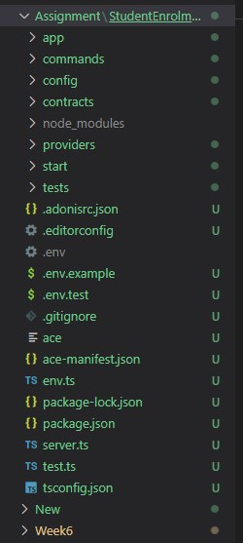

**Task 2: Build the API**

The API needs to be created and available to implement certain endpoints as needed by the business requirements.

There are multiple API endpoints required for the new project to be evaluated effectively by stakeholders. The student registration system sample information has been provided to you for the back end. You are to implement the different endpoints for the senior developers for review.

**Question 5:**

Start your development server for the API project and show the screenshot below

**Screenshot of command to start server and of server running:**

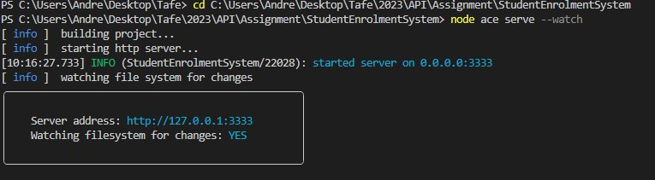

**Question 6:**

1. Create an API endpoint /students which implements the GET method to retrieve all the students currently registered.

Provide the JavaScript controller file you created to implement this endpoint for submission.

1. List two features of the GET method

**Question 7:**

Create an API endpoint /students/{id} which implements the GET method to retrieve a single student from the system using a studentID. Provide the JavaScript file you created to implement this endpoint for submission.

**Question 8:**

* 1. Create an API endpoint /students which will allow you to add a new student using POST. Provide the JavaScript file you created to implement this endpoint for submission.
  2. List two features of the POST method

**Question 9:**

* + - * 1. Create an API endpoint /students/{id} which uses PUT and an id to update a student's details should they need updating. Provide the JavaScript file you created to implement this endpoint for submission.
        2. List two features of the PUT method

1. Create a route for the PATCH method. Provide the JavaScript file you created to implement this endpoint for submission.

**Question 10:**

Create an API endpoint /students/{id} which uses DELETE to delete a student with a given id. Provide the JavaScript file you created to implement this endpoint for submission.

**First API Application Submission:**

You are required to upload 2 files to Learn for your submission for assessment 1:

* Zip file of your entire StudentEnrolmentSystem API project with all project files included and named ***StudentEnrolmentSystem_YourIDNo.zip***
* Word document containing the answers to the written questions listed in this assessment document. The answer document should be named **Assignment1_YourIDNo.docx**